**Muhammad Umar Ahmadzai**

**03/30/2018**

**Two Classes**

**Problem Statement:**

The program is based on two classes, and if and else statements. We define two classes and assign variables. Basically, it is going to show the user three types of drinks, it will take the amount from the user, update the total amount in the dispenser, and update the quantity of the juice.

**Input/Output Description:**

**Below listed are basic input output function, for the use of outputting juices and inputting data from user.**

cout <<"Please chose one of the following items " <<endl;

cout << "1. Orange Juice. (" <<orange.getcost()<<" cents)"<< endl <<"2. Banana Juice ("<<mango.getcost()<<" cents) " <<endl << "3. Manago Juice. ("<<banana.getcost()<<" cents)"<< endl;

cin >> choice;

cout << "Please insert the amount: " << endl;

cin >> useramount;

reg.acceptamount(useramount);

cout << "The sale has ended: " << endl;

mango.makessale();

cout << reg.getcurrentbalance() << endl;

**Algorithm Development:**

We are creating a program which will display the type of juices to the user, but it will be based on classes for security purposes. Two classes will be defined with different variable, each public and private variable is going to connected for each class. In main section, user will input the data, classes will do the rest which include calculation, amount received, balance amount, sale made, and quantity of juices left.

**Program Listing:**

#include <iostream>

using namespace std;

class cashregistertype

{

private:

int cashonhand;

public:

int getcurrentbalance();

void acceptamount (int amountin);

cashregistertype(int cashin=500);

};

int cashregistertype::getcurrentbalance()

{

return cashonhand;

}

void cashregistertype::acceptamount (int amountin)

{

cashonhand=amountin+cashonhand;

}

cashregistertype::cashregistertype(int cashin)

{

cashonhand=cashin;

}

class dispensertype

{

private:

int numberofitems;

int cost;

public:

int getcost();

void makessale();

dispensertype (int setnoofitems=50, int setcost=50);

};

int dispensertype::getcost()

{

return cost;

}

void dispensertype::makessale()

{

numberofitems= numberofitems-1;

}

dispensertype::dispensertype (int setnoofitems, int setcost)

{

numberofitems=setnoofitems;

cost=setcost;

}

int main() {

int choice, useramount;

dispensertype orange (5,75);

dispensertype mango (10,80);

dispensertype banana (15,90);

cashregistertype reg(50);

cout <<"Please chose one of the following items " <<endl;

cout << "1. Orange Juice. (" <<orange.getcost()<<" cents)"<< endl <<"2. Banana Juice ("<<mango.getcost()<<" cents) " <<endl << "3. Manago Juice. ("<<banana.getcost()<<" cents)"<< endl;

cin >> choice;

if (choice==1){

cout << "Please insert the amount: " << endl;

cin >> useramount;

reg.acceptamount(useramount);

cout << "The sale has ended: " << endl;

orange.makessale();

cout << reg.getcurrentbalance() << endl;

}

else if (choice==2)

{

cout << "Please insert the amount: " << endl;

cin >> useramount;

reg.acceptamount(useramount);

cout << "The sale has ended: " << endl;

mango.makessale();

cout << reg.getcurrentbalance() << endl;

}

else if (choice==3)

{

cout << "Please insert the amount: " << endl;

cin >> useramount;

reg.acceptamount(useramount);

cout << "The sale has ended: " << endl;

banana.makessale();

cout << reg.getcurrentbalance() << endl;

}

}

**Sample test run of the program:**

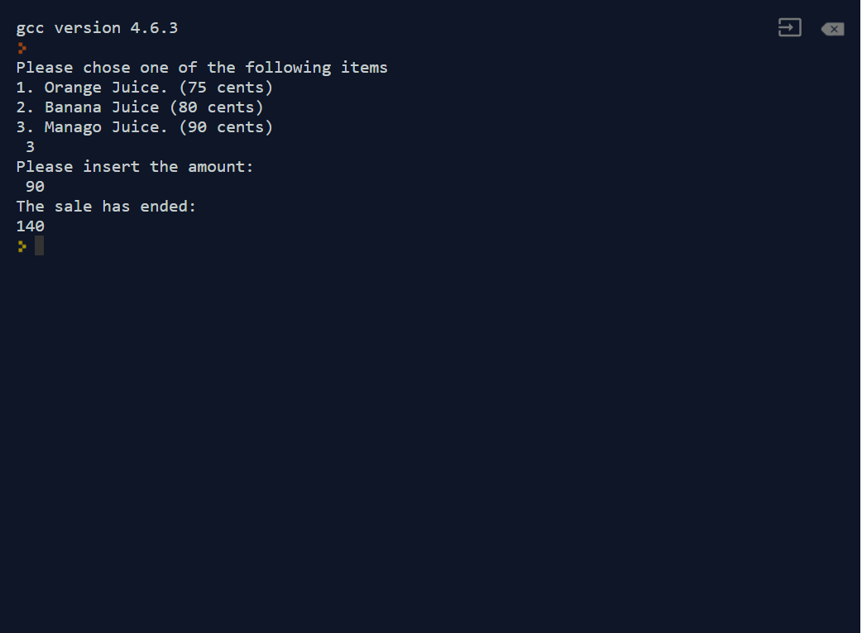

**Observation and Error Handling and general comments:**

Did not faced any errors.

**Conclusion:**

In conclusion, the user will select one of the juice, input the amount and the sale will end.